1)nmap 192.168.1.1Scan common ports
Purpose: The command nmap 192.168.1.1 is used to scan the target IP address 192.168.1.1 and identify common open ports and the services running on them.
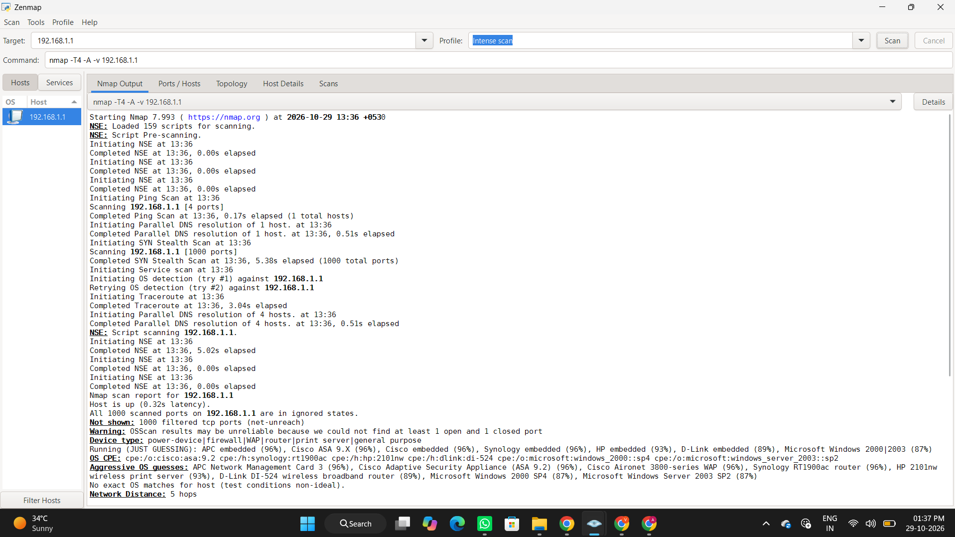
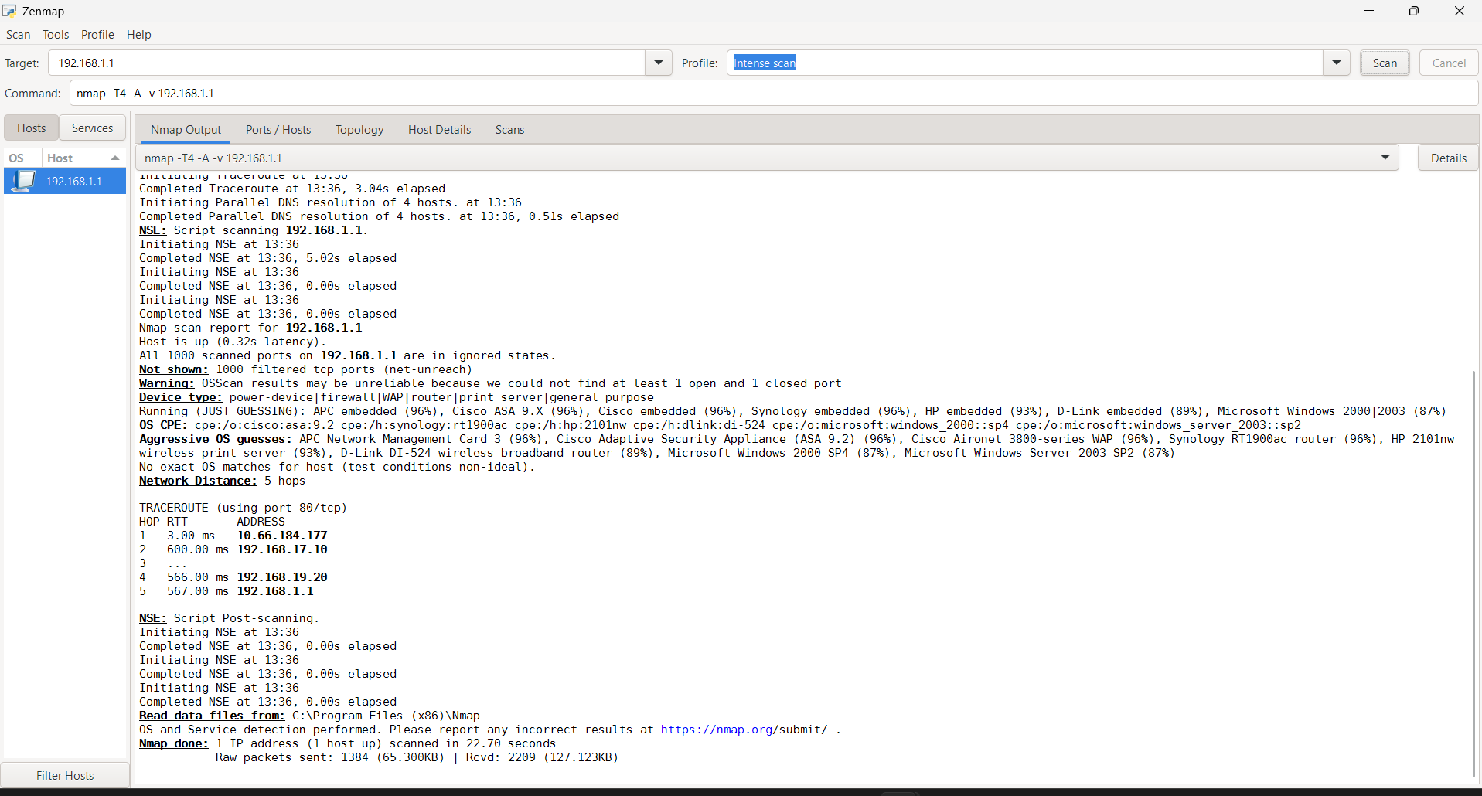

- nmap -sn 192.168.1.0/24 Discover live hosts
Purpose: The command nmap -sn 192.168.1.0/24 is used to discover live hosts (active devices) on a local network without performing a port scan.
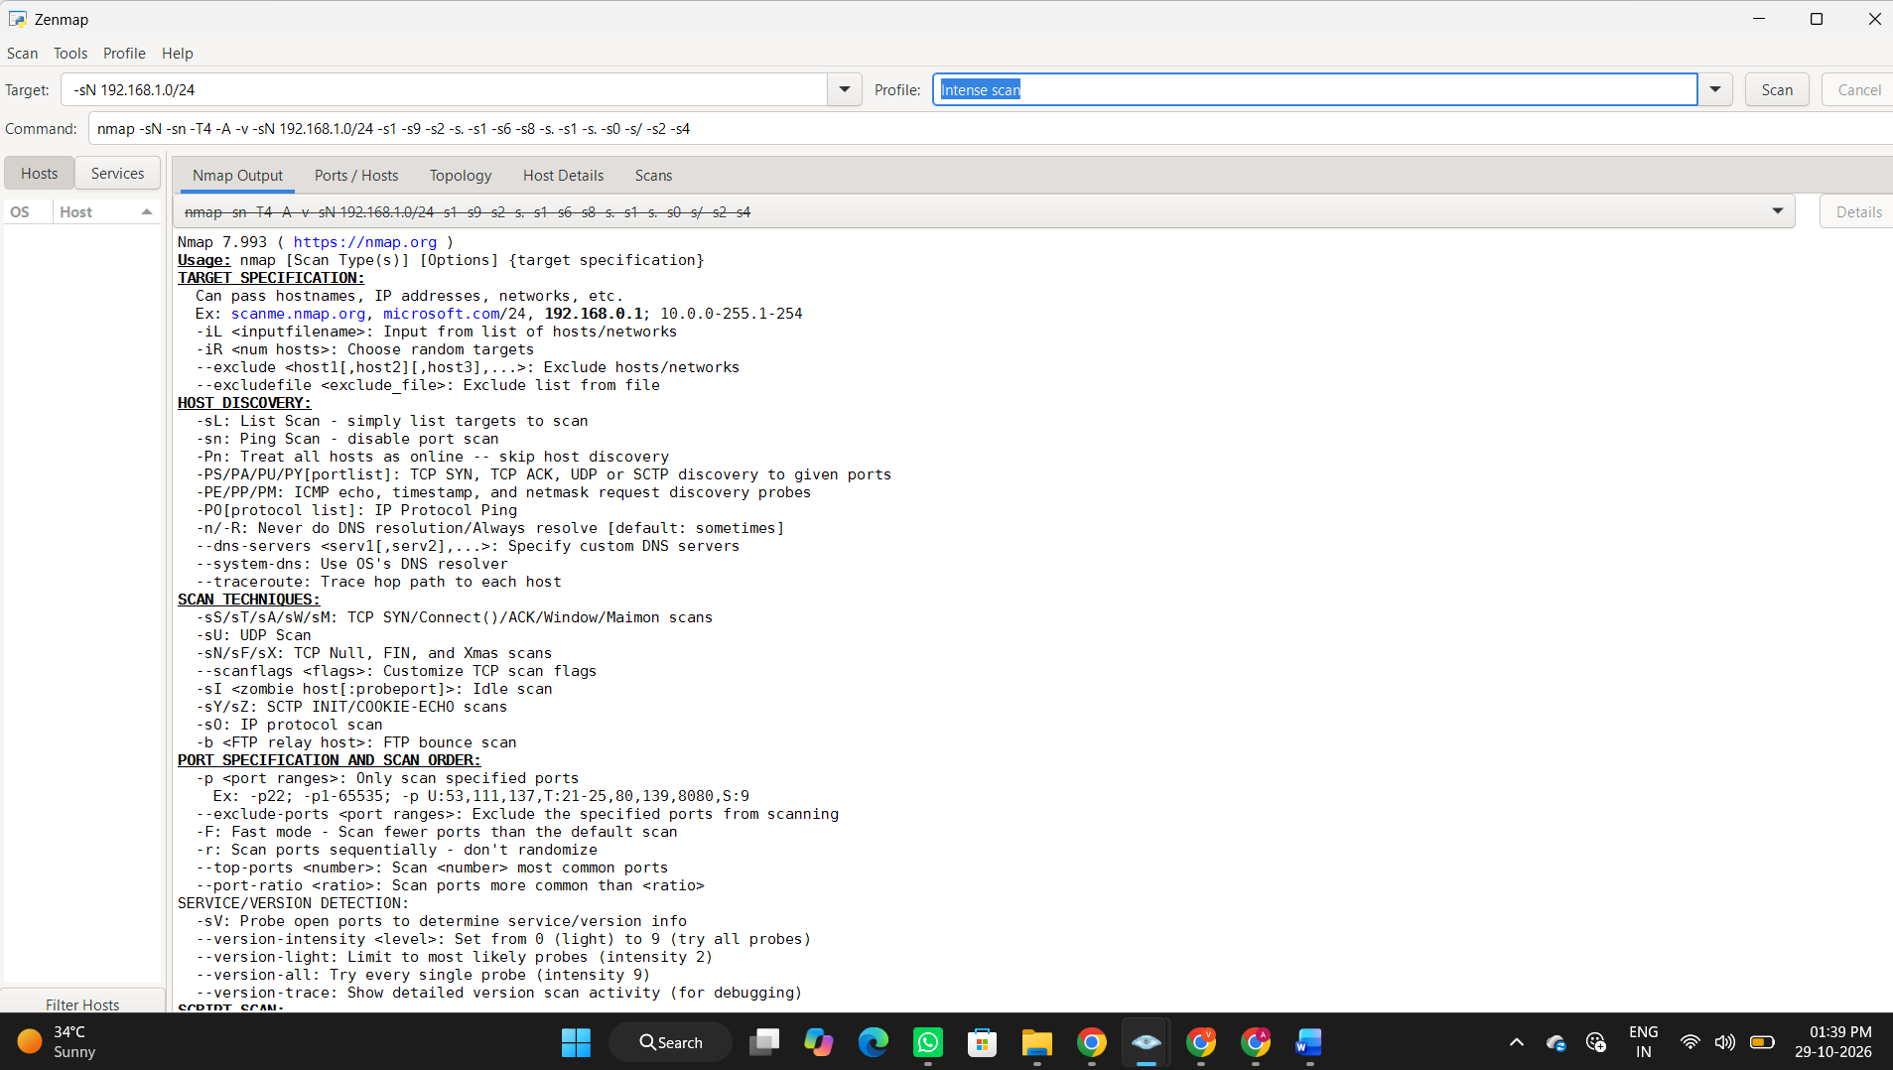

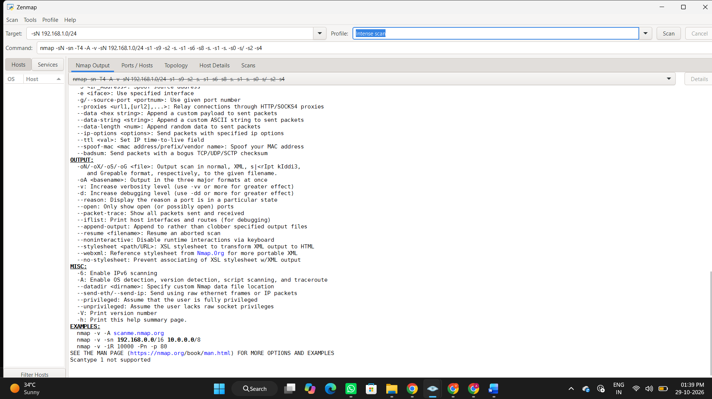

- nmap -sV 192.168.1.1 Detect service versions
Purpose: The command nmap -sV 192.168.1.1 is used to detect the versions of services running on open ports of the target device.
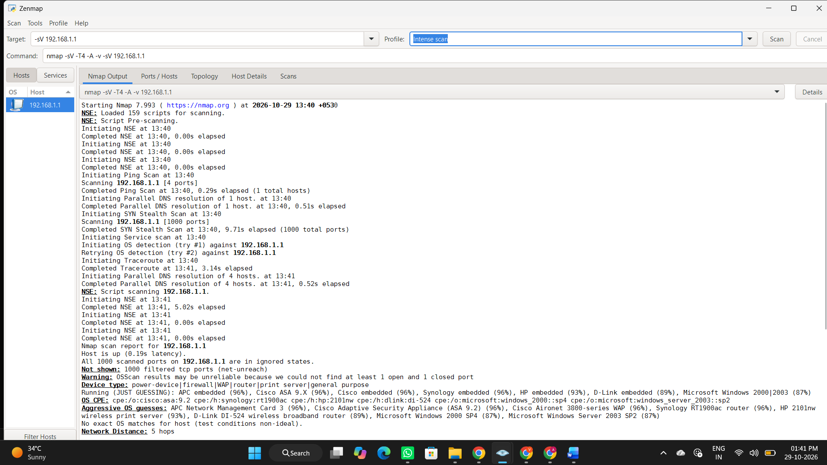
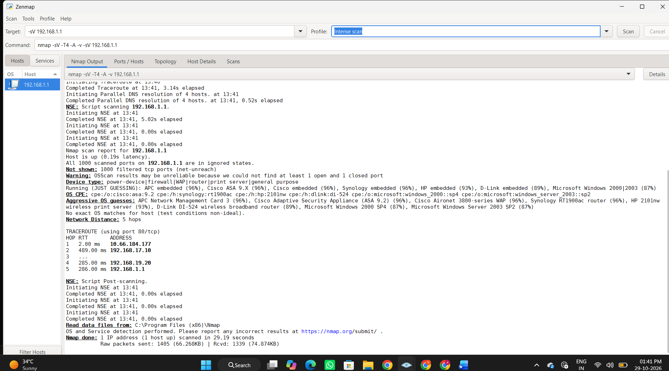
- nmap -O 192.168.1.1 Identify the operating system
Purpose: The command nmap -O 192.168.1.1 is used to identify the operating system (OS) running on the target device.
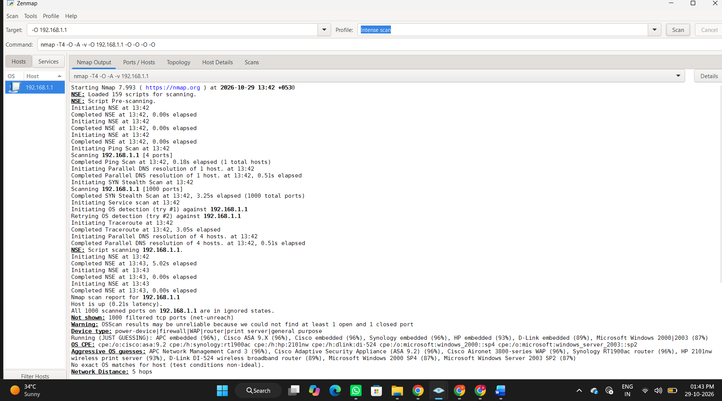
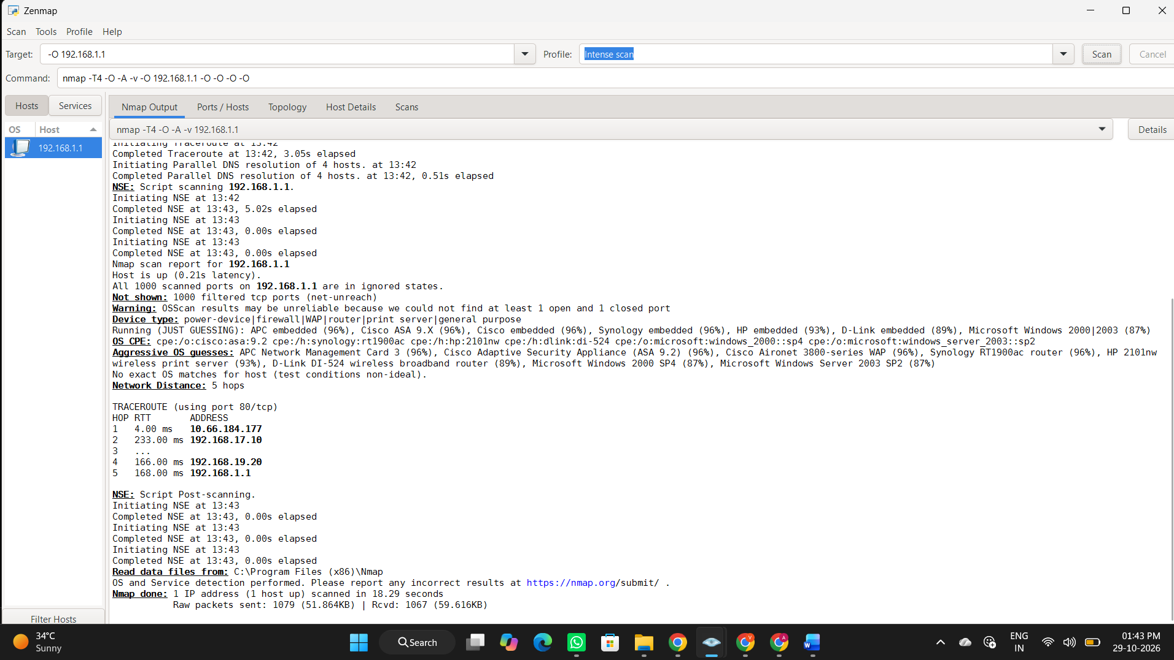

5) nmap -p 80,443 192.168.1.1 Scan specific ports
Purpose: The command nmap -p 80,443 192.168.1.1 is used to scan specific ports (80 and 443) on the target device.
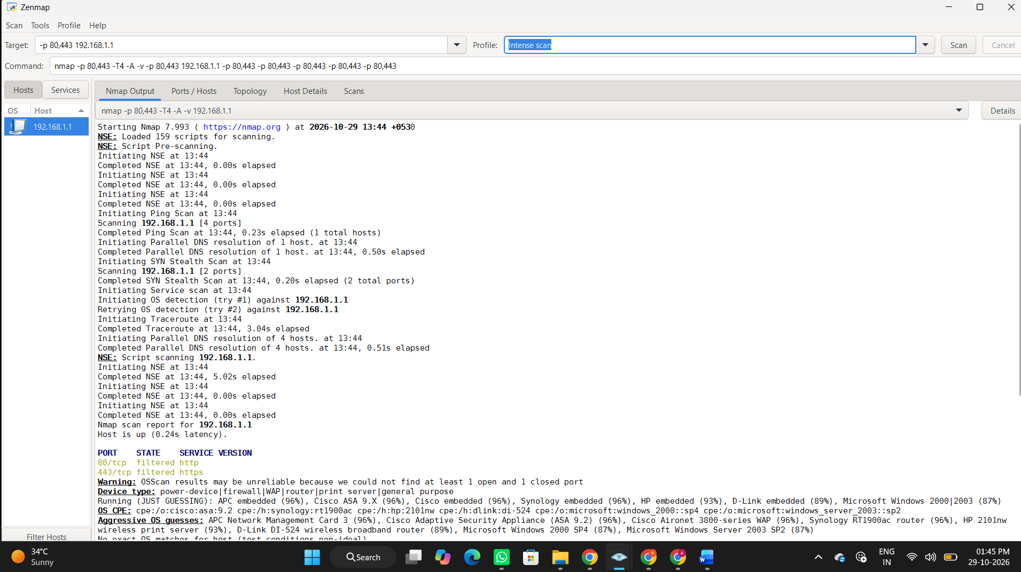
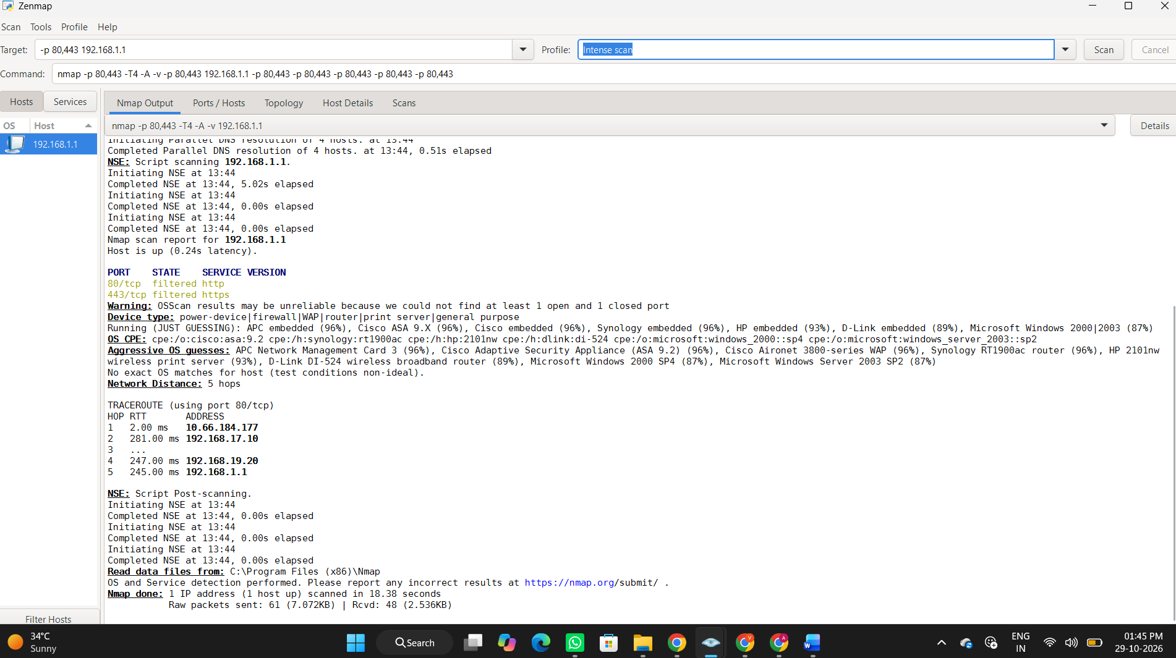

6)nmap -sC 192.168.1.1 Run default NSE scripts
Purpose: The command nmap -sC 192.168.1.1 is used to run Nmap's default NSE (Nmap Scripting Engine) scripts against the target device.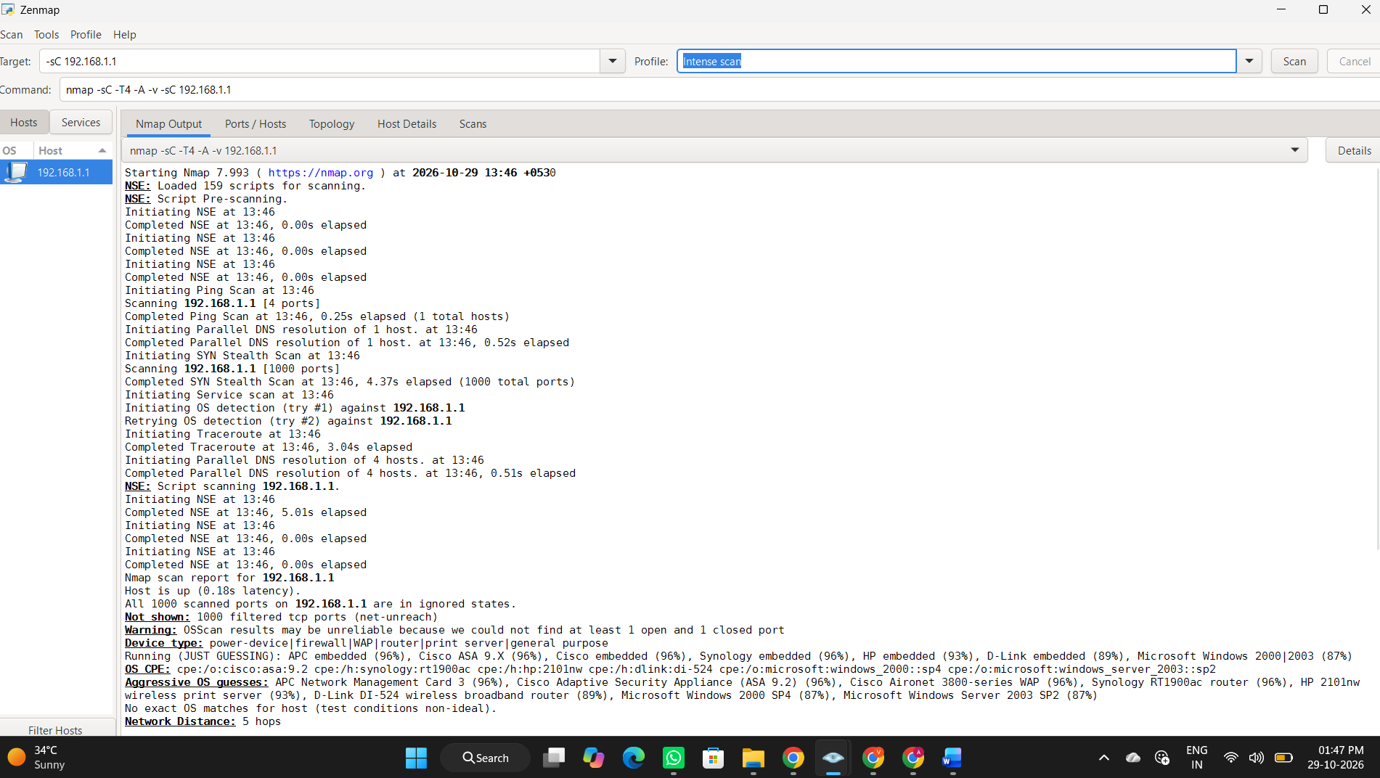
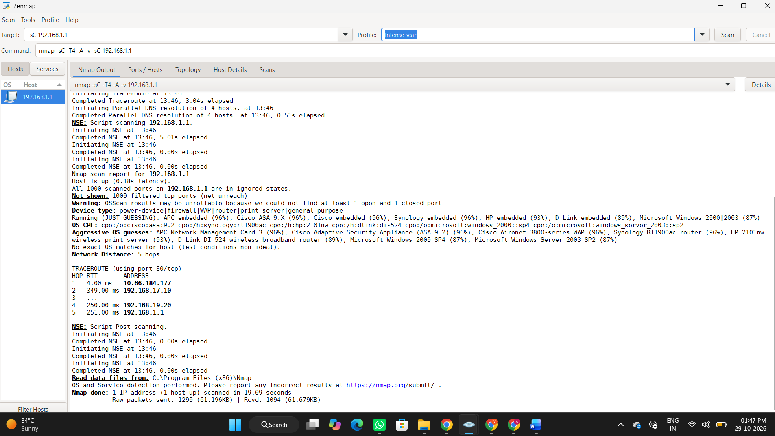

- nmap -Pn 192.168.1.1 Skip host discovery
Purpose: The command nmap -Pn 192.168.1.1 is used to skip host discovery and scan the target as if it is online.
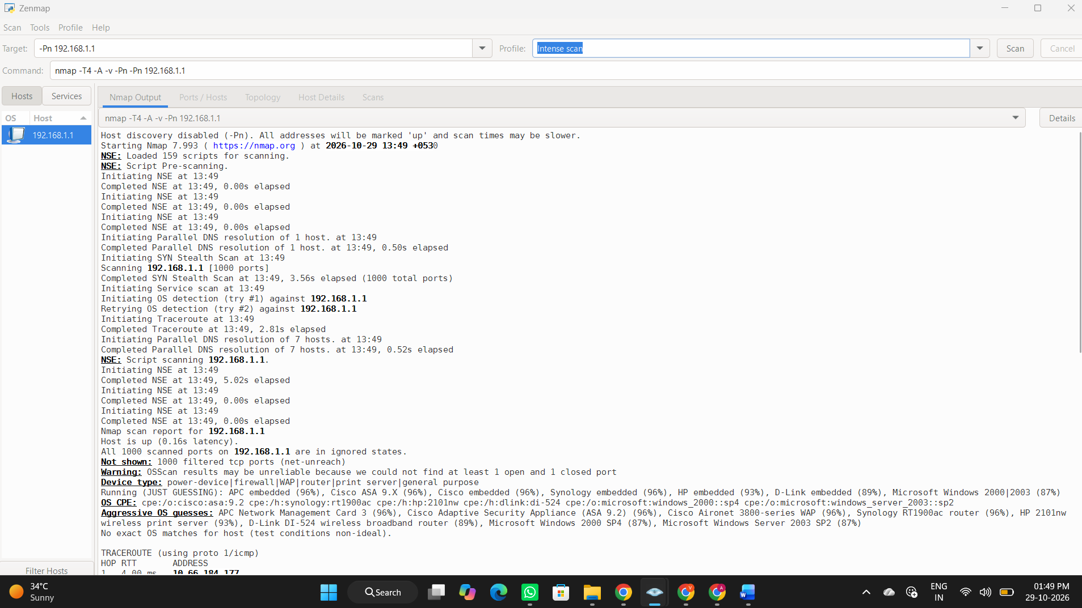
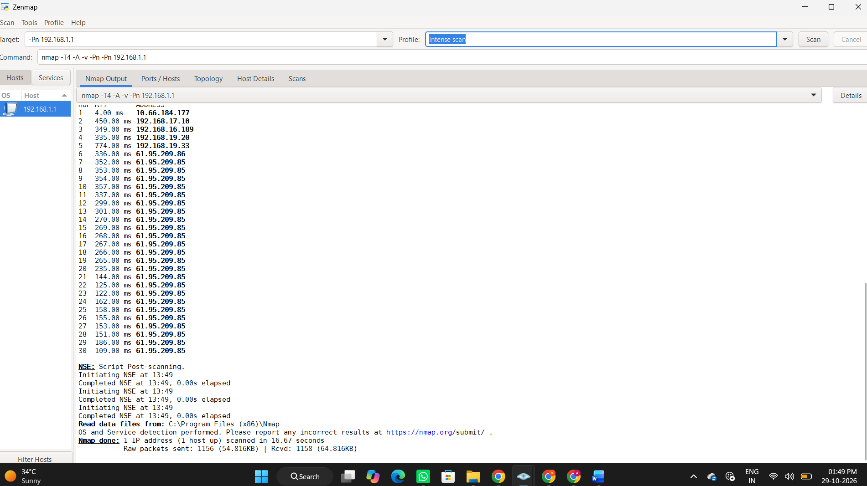

- nmap -oN scan.txt 192.168.1.1 Save scan results to a file
Purpose: The command nmap -oN scan.txt 192.168.1.1 is used to save Nmap scan results to a normal text file named scan.txt.
